The Children’s Home
by J Fuller Higgs, 1889
A1 Annual p716-718
This noisy bustling place has doubtless many and grave faults, but high among the good qualities which more or less atone for these must be reckoned its tender solicitude for the children. This has been shown in many ways, and one of the most characteristic has been the establishment of ‘homes’ as distinguished from schools, asylums and reformatories. Among these, though not the largest, the Children’s Home, in Bonner Road, Victoria Park, London, or as it is now generally called, Dr. Stephenson’s Home, has a place of its own, due in part to the efficiency of its operations, and the interest attaching to the story of its development. It began in a very simple way. Rather more than twenty years ago, then as now, a Wesleyan minister, had been stationed in a very poor neighbourhood south of the Thames. The chapel to which he was appointed had such a meagre congregation, that it was absolutely necessary to work outside of it, and as the young minister was gifted with a powerful and musical voice, he made his first appeal to the lapsed masses by singing to them. His tactics were eminently successful, and his indoor congregations rapidly increased; but day by day the problem of the poor oppressed him, and the question which forced itself to the front was this: can anything be done for the children? – the waifs of the city, the desolate and degraded little ones, destitute of all home comforts, and destined in time to swell the ranks of the criminal population, unless something could be done to save them.
Fortunately for the children Mr. Stephenson was not above working in a small way, and he came to the conclusion that if he could only save a few of them, he would be making a small contribution to the solution of the difficulty. Even this was an enterprise not to be lightly undertaken, and it was only after anxious deliberation that a cottage was rented in Church Street, Waterloo Road. Ingenious contrivances had to be resorted to, in order to make the premises fit the work, or, to speak more correctly, the work fit the premises. The only playground available was the entry at the side, the dining-room was a converted stable, the dormitory a reformed loft. But however humble the beginning, it was a work destined to last and to grow.
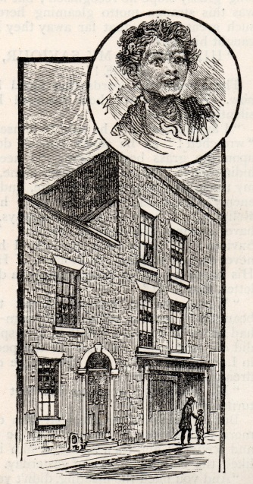 The beginning of the Children’s Home

Dr. Stephenson had been greatly impressed by the fact that the poor children with whom he came into contact wanted most of all ‘a home’; and it was the desire to give them some at least of the comforts of home life that lay at the bottom of his enterprise. The idea was then a new one in England, although it had been tried in Germany by Dr. Wichern at the Rauhe Haus; but as an improvement on the German system, Dr. Stephenson put at the head of each house ‘mothers’ instead of ‘brethren’. This plan has been adopted by others, but to Dr. Stephenson belongs the honour of having introduced it into this country.
For two years the work was carried on at Church Street. The twenty five boys that had been gradually picked up were made as comfortable as possible, and since no other work was available in the cramped premises, were employed at wood chopping. The two cottages in Church Street having served their turn, were abandoned in 1871 for larger and more convenient premises in the neighbourhood of Victoria Park. There were now workshops available, so that the boys might be taught useful trades; and the increased space at his disposal enabled Dr. Stephenson to admit girls to the privileges of his institution. From that time there has been a steady though gradual development in the work; but it would take too long to describe how this has been added, and that has been altered, as means permitted or as needs required. It has vastly improved since I first saw it some twelve or thirteen years ago; but now all the ground available has been covered with buildings, and a brief description cannot fail to be interesting.
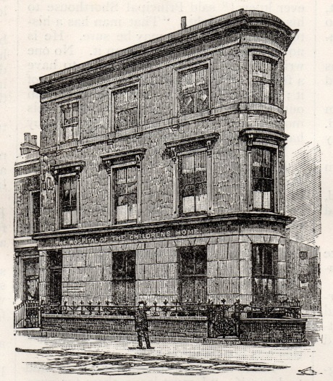 The hospital
Passing along Bonner Road from the Cambridge Heath station of the Great Eastern Railway, you notice on the left hand side, a large corner house – ‘The Hospital of the Children’s Home’, but this presents no special features, and it is noticeable only for the skill with which an ordinary house has been adapted to the purposes of an infirmary. It is within an easy distance of Victoria Park, so that in summer time the little invalids may feast their eyes on flowers and trees. A very little way further along the road you come to a plain iron gateway, which makes a broad opening between two terraces of respectable middle-class houses. The terrace to the right of the gateway bears along the front in large letters the inscription ‘The Children’s Home’. The houses are devoted to the use of the girls and have been either presented by kind friends, or purchased as the funds permitted. Each house is a separate home, having its own individual life; and to illustrate this by a very trifling detail, I may mention how one of the boys I was talking to outside this terrace pointed out to me that the girls at one of the houses had cleaned their venetian blinds, and so, added my informant, ‘the other girls will have to keep up with them’.
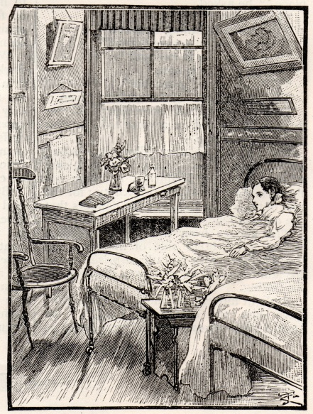 In the hospital
Entering the gateway, you have on one side of you the offices where all the clerical work of the establishment is carried on; and on the other side a blank wall, which has been very artistically relieved by ornamental transport work, and little beds of flowers. At the end of this broad entry you find yourself in a large open playground, paved with wood blocks, and surrounded by buildings. In front of you are the workshops, labelled, “Industrial Department”; to your left, the very pretty chapel and school; to your right the building that accommodates the laundry, and between these, at all points, the homes occupied by the boys. If you happen to arrive during playtime, you may expect to see a very animated picture, but of course the main interest of the Home to an outsider is to see the boys at work at their various trades. On the ground-floor of the Industrial Department there is an engine-room and the printing shop, containing three large, and one small, printing machines, worked by steam power, as well as a hand press. The printing work is perhaps the most important of the industries carried on at the Home. The whole of the top floor is devoted to the compositors, and the folders occupy a portion of the first floor, the centre of which contains the shoemaking park of the community.
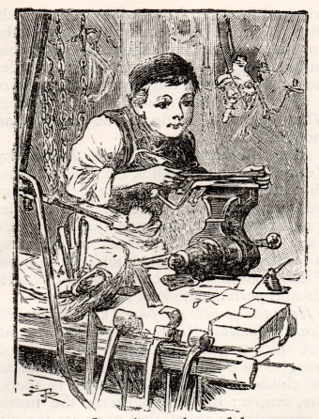 Learning to be useful
Soon after the Home was started the need of a Magazine to advocate its claims was noticed, and the Children’s Advocate was commenced. In 1880 this was enlarged, and is now published under the title of Highways and Hedges. It is really a very attractive and interesting serial. Other magazines are printed here, as well as a large number of tracts and booklets, setting forth the work of the Home, and its claims upon the benevolent. Some of these, written by Dr. Stephenson and Mr. Pendlebury, M.A., contain very touching and pathetic accounts of the life stories of some of the little ones who have found a shelter under their kindly protection.
The carpenter’s shop is to the left of the building, with the castellated roof, and the door in the right hand corner leads to the swimming bath. When all the little mechanics are at work, the scene is one of bustle and activity. Some boys only work half time and spend the rest of their working hours in school; those that are older, of course, work on all day.
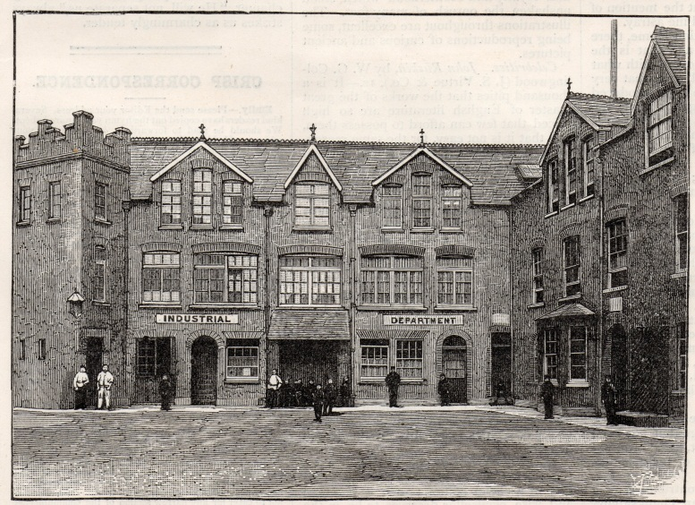The playground
Now let us enter one of the Homes and notice the arrangements. On the ground floor there are two rooms, called respectively the dining-room and the day-room. The latter is fitted with small cupboards, in which each boy may stow away his own particular treasures. Several of these are open, so we may get some idea of the tastes and habits of the lads from the way they arrange their cupboards. On the next floor, you find a dormitory, and also the “mother’s” room, which is placed as nearly as possible in the centre of each house. If it should happen to be a Saturday afternoon when you call, you will see the clean linen and the best clothes carefully placed beside each little bed. Returning once more to the ground floor, you ought to take a peep at the lavatory, to see how complete are the arrangements for the comfort of the children.
Among other questions, I asked Mr. Stone, the Assistant Secretary, if he would mind telling me the routine of the daily life of the Home. The boys rise at six, and at half-past six the muster roll is called over. Then those who are in trades go to the workshop; the rest have to do the necessary housework of the respective homes. Breakfast is served at eight, and at half past eight all the inmates of the Home meet in the chapel for prayers. School begins at nine, and at the same hour the mechanics resume their toils until dinner time. After dinner there is the usual interval for play, and then school and work go on till five or half-past five. In the evening, there are singing rehearsals, the swimming bath, an occasional lecture or entertainment, and recreation of an instructive character.
It only remains to add that each home contains from twenty-five to twenty-eight boys or girls. All the houses are arranged on the same principle, with slight modifications, as in one which contains a large room set apart for the use of the Committee, and used as a dining-room by the officials of the Home. This room is very artistically, though inexpensively decorated, and contains portraits of Dr. Stephenson and of Mr. James Barlow, who was one of the most munificent donors to the Home. Mr. Barlow presented the Home with a farm in Lancashire, consisting of a substantial building and a hundred acres of land, as well as £5,000. This brought about the establishment of the branch Home, now known as Edgeworth. But the mention of Mr. Barlow’s name has led me astray.
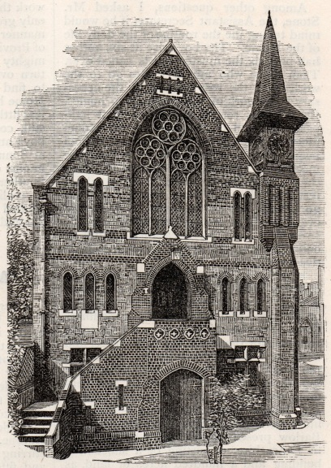 The Home church
Before leaving the London Home, there is one place more to visit, and that is the chapel. It is very easy to see with what care it has been designed, and what very pretty artistic effects have been produced by simple means. The organ is a gift, the handsome brass lectern is a gift, and so is the very beautiful font that is the latest addition to the treasures of the little sanctuary. Underneath the chapel is the school, no underground; and here the contrivances for educational purposes are as perfect as possible.
Of necessity I have occupied so much of my space in describing the central Home in London, that I have no room now to deal at any length with the Industrial School, carried in Parrock Hall, near Gravesend, or the Agricultural Home at Edgeworth, in Lancashire. Besides these, there is a smaller branch as Ramsey, in the Isle of Man, and a homestead for emigrant boys and girls near Hamilton, Canada. AT these various branches, and in London, there are being sheltered, fed, educated and helped out into life, about seven hundred children.
Somewhat apart from the general idea of the Home is the Orphanage that has been established at New Oscott, near Birmingham. This is the outcome of the generous gift of £10,000 from Mr. Jevons, of Birmingham; and a further contribution of a like sum from the Wesleyan Thanksgiving Fund, placed ample funds at the disposal of the Committee. This new Orphanage is to be, when complete, one of the finest examples of a village home in the country; and by permission of the Queen, it has been called The Princess Alice Orphanage.
Such, in very brief, rough outline, is the work that is being carried on, and it is still only growing. It began in a very humble manner; and under the favouring influences of Providence it has already proved itself a mighty power for good. You have only to turn over a few numbers of its Magazine to find instances of the benefit that the Home has been able to confer on the helpless little ones of this great city. Or, better still, contrast the happy, rosy faces of the boys and girls at play in the quadrangle at Bonner Road with the poor little urchins in one of the squalid alleys of Eastern or Southern London, and that will help you to realise what good has been accomplished by the Children’s Home and is kindred institutions.

